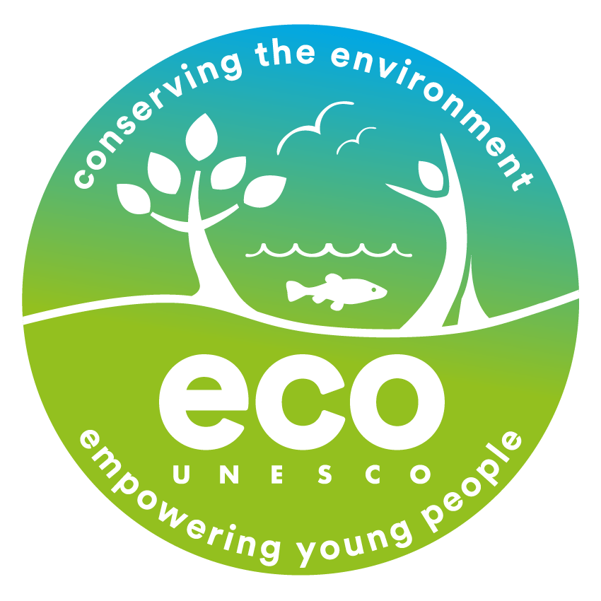
ECO-UNESCO
Ireland’s Environmental Education and Youth Organisation

Opportunities at ECO-UNESCO

Programme Coordinator – Young Environmentalist Awards
This is a great opportunity to join an organisation that is making a real difference to the lives of young people and the environment. If you have a passion for youth development, environmental education, are enthusiastic, motivated with project management and event skills then we would love to hear from you.

Salary: Dependent on experience. A salary scale will apply.
Contract: 2 Year Fixed Term with a view to extension
Reporting to: The Operations & Development Manager
Location: 9 Burgh Quay, Dublin 2

About ECO-UNESCO
ECO-UNESCO is Ireland’s environmental education, training and youth organisation. Through the provision of a wide range of environmental programmes and services, ECO-UNESCO delivers a wide range of youth, education and training programmes across Ireland to promote the personal development of young people through practical environmental projects. Working with over 10,000 young people annually we seek to raise awareness of environmental issues.

The Role:

As Young Environmentalist Awards Programme Coordinator you will be responsible for coordinating and delivering the Young Environmentalist Awards (YEA), ECO-UNESCOs flagship programme.

The Young Environmentalist Awards is Irelands leading environmental awards programme for young people recognizing and rewarding their work in environmental protection through local environmental action projects. Involving over 4000 participants each year, the Awards engage young people through schools, youth groups and communities across Ireland, supporting them to take action on environmental issues and celebrating their passion and creativity.

The Programme Coordinator is the cornerstone of the Awards, taking ownership of the programme delivery from inception to completion, ensuring the programme goals of environmental protection, youth empowerment are met throughout. This is a varied and challenging role, but one that rewards in equal measure.

Reporting to: | Operations and Development Manager
Location: | ECO-UNESCO’S Headquarters at 9 Burgh Quay, Dublin 2 with travel required
Time commitment: | Full/time (35 hours)  Flexibility is required as the role will include evening and weekend work.  Fixed Term Contract (2 years) – subject to completion of a 6-month probationary period and to continued funding
Other Terms & Conditions
- Fixed Term Contract (2 years)
- 35 hours per week over 5 days (flexibility required for evening & weekends as required)
- 21 days annual leave per annum (increasing to 25 years over time)
- Access to company PRSA Pension scheme (with employer contribution after qualifying period)
- Use of a Mobile Phone & Laptop
- Access to company car (when needed for work travel purposes)
Key responsibilities
Programme Management
- Running all phases of the Young Environmentalist Awards (YEA) programme, Irelands all island environmental awards programme for 10–18-year-olds including.
  - Administration
  - Promotion
  - Recruitment & Registration
  - Support & Training incl.
  - - YEA Mentor (Local volunteer/group leader) support
  - - YEA Information provision
  - - YEA Roadshow and group visits
  - - Leader/teacher/youth trainings
  - - Support of project groups
  - Judging and evaluation
  - - Managing full judging process
  - - Managing ECO-Dens semi-finals events
  - Showcase & Awards
  - - Event Management of Annual Showcase events.
- Driving increased numbers of projects and participants taking part in the programme from secondary schools, youth groups, Youthreach Centres and community groups on an a regional (all-Ireland) and per category basis.
- Supporting and up skilling YEA Mentors and YEA Groups in the use and implementation of the ‘6-Steps to Success’ framework for developing their local environmental action projects & increasing use of the YEA Transition Year module and supporting teachers in its use.
- In conjunction with the Communications Officer, organising ECO-Dens in four regions and the Annual Young Environmentalist Showcase and Awards Ceremony.
- Supporting the development and progression of Young Environmentalist Awards groups in the establishment of ECO-UNESCO clubs and supporting these Clubs as part of the national network of ECO-UNESCO Clubs.
- Promote use of Young Environmentalist Handbook and produce other educational resources as required.
- Monitoring and Evaluating the programme and its impact on an ongoing basis and carrying out an end of year evaluation and report.
- Running specific funded YEA related programmes in conjunction with Local Authorities.
- Liaising with and supporting ECO-UNESCO’s other Youth programmes to participate in the YEA programme.
- In conjunction with the National Director and Operations Manager, research and establish new elements for the Young Environmentalist Awards programme.
- Assisting with other areas of ECO-UNESCO’s programmes and service work
- Managing the administration of the programme, including associated IT systems.
Fundraising, Grant Writing & Reporting
- Writing funding grants & proposals for key stakeholders, including subsequent reporting on an annual basis.
- Identify funding and sponsorship opportunities for the Young Environmentalist Awards and related programmes, developing and implementing a fundraising and sponsorship strategy in conjunction with the National Director.
Other
- Liaising with schools, youth groups, ETB’s, media partners and others
- Promoting ECO-UNESCO through talks, workshops, seminars and presentations
- Reporting on a regular basis to the National Director, Board of Directors and Government departments
- Undertaking any other such relevant duties as directed

This role description is not to be regarded as exclusive or exhaustive. It is intended as an outline indication of the areas of activity and can be amended. ECO-UNESCO reserves the right to reassign staff as appropriate and necessary.

Personal Specification (E – Essential; D- Desirable)
Qualifications | 3rd Level Qualification in a related field – in sustainable development/environmental studies or science / ecology/biology/ geography/ education |  | E
 | An education or youth work qualification would be beneficial |  | D
Experience
At least 2 years work experience in direct work with and young people (10-18); youth work, education and/or environmental education/sustainable development and /or in a similar youth scheme/programme |  |  | E
Experience in developing and delivering youth, education and training programmes |  |  | E
Demonstrable organization skills, having managed multiple priorities and adherence to deadlines |  |  | E
Budgetary management experience from initial planning through to end of project reporting. |  |  | E
A strong interest in the environment international development and working with young people. |  |  | E
A full, clean driving license. |  |  | E
Knowledge, Skills and Disposition
Knowledge of the youth work sector and education system in Ireland |  |  | E
Knowledge of education for sustainable development/development education in Ireland |  |  | E
Knowledge of international development issues relating to Sustainability and the SDG’s |  |  | D
Excellent organisational skills |  |  | E
Excellent communications and interpersonal skills |  |  | E
Excellent report writing, analytical and computer skills |  |  | E
Ability to work to tight deadlines and under pressure |  |  | E
Ability to manage a complex workload |  |  | E
Working knowledge of IT systems (e.g., Salesforce, Office 365) |  |  | D
Ability to critically analyse data and make appropriate decisions  Ability to work as part of a team |  |  | E  E
Disposition
Be a self-starter with a positive, can do attitude at all times |  |  | E
Be dependable and flexible |  |  | E
Be committed to working as part of a team with a commitment to the values and principles of ECO-UNESCO |  |  | E  E
Be able to take direction |  |  | E
Position Start Date: | Immediate
Interview Date:  Remuneration: | Early applications are encouraged as interviews will be held regularly  Starting Salary (commensurate with experience)

Closing Date for receipt of Applications – 12pm Tuesday 2 February 2021
Interviews are provisionally scheduled to be held week commencing 8 February 2021

Successful applicants may be requested to prepare a short presentation during the selection process.
Please send a copy of a completed Application Form with a Cover Letter to: recruitment@ecounesco.ie
Please mark in subject line Employment Opportunities – Programme Coordinator - YEA (Private and Confidential)

Applicants may be placed on a panel for positions that may arise in the future.

By completing and submitting this form you consent to ECO-UNESCO processing the personal data provided to assess this application for employment. No further processing of your data will occur beyond this purpose.
ECO-UNESCO will retain unsuccessful applications for up to 12 months, after which it will be deleted.

ECO-UNESCO

APPLICATION FOR EMPLOYMENT

Please complete all sections of the form. CV’s are not accepted, and no application will be processed if the form is incomplete.

Position applied for: | Programme Coordinator – Young Environmentalist Awards
Where did you see the post advertised?

Personal Details
Title
Surname
Forename(s)
Address
Phone
E-mail

Current or Last Employment
Position
Employer
Date from/to
Summary of achievements

Previous Employment
Employer: | From: | To: | Position:
Summary of achievements:

Employer: | From: | To: | Position:
Summary of achievements:

Employer: | From: | To: | Position:
Summary of achievements:

Employer: | From: | To: | Position:
Summary of achievements:
Employer: | From: | To: | Position:
Summary of achievements:

Education and Qualifications
School / college / university… | From | To | Qualifications

Language Skills
 |  | Fluent | Moderate | Learning | None
ENGLISH | Speaking
 | Writing
IRISH | Speaking
 | Writing
Add additional languages (with levels), or comments:

Relevant Experience
Detail how your skills and experience meet the requirements set out in the Job Description
Youth work and/or educational experience in formal/non-formal settings | Please provide details…
Complex programme management experience, including participant recruitment | Please provide details…
Facilitation & training experience | Please provide details…
Supervisory and/or coordination experience | Please provide details…
Relevant 3rd level qualification | Please provide details…
Relevant interests | Please provide details…

Experience & Skills Checklist |  | Yes/No
Experience
At least 2 years work experience in direct work with and young people (10-18); youth work, education and/or environmental education/sustainable development and /or in a similar youth scheme/programme | Essential
Experience in developing and delivering youth, education and training programmes | Essential
Demonstrable organization skills, and a track record in managing multiple priorities and adhering to deadlines | Essential
Budgetary management experience from initial planning through to end of project reporting. | Essential
A proven track record in the management or delivery of large-scale projects including in securing and reporting on funding | Essential
A strong interest in the environment international development and working with young people. | Essential
A full, clean driving license. | Essential
Knowledge and Skills
Knowledge of the youth work sector and education system in Ireland | Essential
Knowledge of education for sustainable development/development education in Ireland | Essential
Knowledge of environmental issues and the Sustainable Development goals | Essential
Excellent IT skills. Experience with Office 365 and/or Salesforce an advantage | Essential
Excellent communications and interpersonal skills | Essential
Excellent report writing and analytical skills | Essential
Ability to work to tight deadlines and under pressure | Essential
Ability to manage a complex workload | Essential
Ability to critically analyse data and make appropriate decisions | Essential
Disposition
Be a self-starter with a positive, can do attitude at all times | Essential
Be a problem solver and creative | Essential
Be dependable and flexible | Essential
Be committed to the values and principles of ECO-UNESCO | Essential
Be committed to working as part of a team | Essential
Be able to take direction | Essential

Statement in support of your application
Please outline your motivations for wanting this post.

Additional Questions
If successful, what is the earliest date that you could start the job?
Do you hold a current, full and clean Driving License valid in the Republic of Ireland? |  |  | Yes / No  (essential due to travel requirements of the role)
References
Please provide details of two referees, including your present or most recent employer. We will not contact your referees until we have informed you and received your consent. Please ensure you have your referee’s permission to share their contact information.
1 | Name
 | Position
 | Address
 | Tel. No.
 | E-mail

2 | Name
 | Position
 | Address
 | Tel. No.
 | E-mail

Declaration
I declare that the statements made by me in this application are true and that the accuracy thereof shall be a condition of any contract of employment offered to me by ECO-UNESCO:

Signature of Applicant
Date

Please e-mail your completed form to recruitment@ecounesco.ie or return it by post to:

Employment Opportunities

(Programme Coordinator - YEA)

ECO-UNESCO

9 Burgh Quay

Dublin 2

Ireland

Closing date for applications is 12pm Tuesday 2 February 2021.

