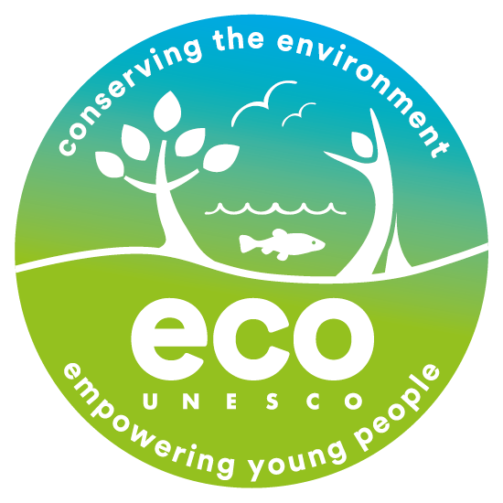

Opportunities at ECO-UNESCO

Communications Coordinator

We are seeking to recruit a Communications Coordinator. This is a great opportunity to join an organisation that is making a real difference to the lives of young people and the environment. If you have a passion for youth development and environmental education, are enthusiastic, motivated with great people management and organisation skills then we would love to hear from you.

Employment: 3-year contract with a view to permanency (subject to continued funding)
Hours: Full-time position, 35 hours per week

Location: 9 Burgh Quay, Dublin 2, D02 FD85 – hybrid working options
Salary: Starting salary dependent on experience
Probationary period: 6 months

About ECO-UNESCO - Background
We are a leading environmental education and youth organisation working to channel the passion, creativity, and energy of young people into positive environmental action. Through our range of programmes and services we inspire, educate, empower, and support young people to act. Working with over 10,000 young people annually we seek to raise awareness of environmental issues.

The Role
This is a position of responsibility within ECO-UNESCO. As Communications Coordinator you will be responsible for coordinating ECO-UNESCOs communications, PR, and marketing work with an aim of building public awareness of ECO-UNESCO’s programmes and managing engagement with members, participants, the general public and the media.

Main duties and responsibilities:
The Communications Coordinator will carry out the following duties:

- Develop and implement an annual communications and PR plan with KPI’s and ensure targets are met.
- Collaborate with the team to develop and implement communications strategies that promote ECO-UNESCO’s youth programmes and services, our education and training, supporter and membership programmes to key stakeholders including annual promotional drives, annual mailshots, email marketing; google ad words, attendance at external events; advertisements, the creation of communications calendars with a view to increasing registrations and sign ups.
- Maintain a consistent brand and voice in all ECO-UNESCO’s communications and ensure branding guidelines are in place, design report templates, infographics, and other visual representations of ECO-UNESCO’s work
- Maintain ECO-UNESCO’s social media presence, including content creation and curation with a view to growing ECO-UNESCO’s reach on our social media platforms. Monitor ECO-UNESCO’s presence on social media and create social media reports (Analytics and Google Analytics). Design and post social media pieces and videos for each platform (Adobe package & Canva) including production of 'story-telling' videos, regular blogging etc.
- Manage the overall maintenance and updating of ECO-UNESCO’s website ensuring information is up to date; monitor its effectiveness, drive growth in visitors to the site including in e-commerce and the ECO-Academy (ECO-UNESCO’s online learning hub)
- Manage and support creation and design of all print and electronic materials, including Monthly e-newsletter, regular programme updates and action alerts.
- Produce and edit all publications and marketing and promotional leaflets and produce ECO-UNESCO’s Annual Report; the annual prospectus; annual newsletter and other publications as required.
- Maintain ECO-UNESCO’s digital library with photos and videos of ECO-UNESCO events and activities
- Assist with production of ECO-UNESCO events including event announcements, invitations, programmes and signage and work closely with the YEA Coordinator to produce the Young Environmentalist Awards
- Promote ECO-UNESCOs work; organise ECO-UNESCO’s presence at external events and identify and coordinate advertising opportunities
- Work with management to identify media opportunities and implement campaigns around key programs and issues. Oversee ECO-UNESCOs PR work including liaising with and creating media contacts; writing press releases & preparing press briefings; organising Photocalls carrying out Media monitoring; liaising with external PR contractors.
- Support the organisations marketing and fundraising efforts including creating packages for potential sponsors and support the organisations membership and supporter programme.
- Measure and report on the effectiveness of communications activities, engagement levels, and progress

Other
- Undertake any other such relevant duties as may from time to time arise
- Maintain clear records of all contacts, activities and funds raised
- Deal with general queries from the general public and members

This role description is not to be regarded as exclusive or exhaustive. It is intended as an outline indication of the areas of activity and can be amended. ECO-UNESCO reserves the right to reassign staff as appropriate and necessary.

The Ideal Candidate

Qualifications
3rd Level Qualification in a related field or equivalent industry experience E

Experience
At least 2 years’ experience in marketing, communications, event management, developing online content E
Experience of working in information provision and with the media E
Experience with online marketing tools, social media platforms, and publishing software E
Experience in event management D
Experience working with a young target group (i.e. second level and youth work sectors) D

Knowledge, Skills
Excellent organisational skills E
Excellent communications and interpersonal skills E
Excellent writing, analytical and computer skills E
Ability to work to tight deadlines and under pressure E
Ability to respond adeptly to rapidly changing priorities and successfully manage multiple initiatives at once E
Meticulous attention to detail and excellent time/task management skills E
Working knowledge of Salesforce or a similar Customer Relationship Management system D
Working knowledge of graphic design packages/methodologies D
Knowledge of the youth work sector and Irish education sector in Ireland would be an advantage D

Disposition
Demonstrated interest in ECO-UNESCO’s mission with a commitment to the values and principles of ECO-UNESCO E
Be committed to working as part of a team E
Be a self-starter with a positive, solutions-focused attitude E
Be dependable and flexible E

E = essential; D = desirable

ECO-UNESCO has an Equal Opportunities policy and all employees are expected to develop an understanding of and commitment to equal opportunities.

Key information about this role
- The starting salary will depend on experience.
- This is a full-time role over 35 hours per week. Flexibility is required for occasional evening and weekend working.
- The position is based at ECO-UNESCO’s Offices at 9 Burgh Quay, Dublin 2 with hybrid working options
- The role may require occasional nationwide travel
- 21 days annual leave per year which increases annually to a maximum of 25 days per year.
- An employer matched pension scheme is available after a qualifying period.
- An Employee Assistance Programme is available to all staff.
- The position has an immediate start date
How to apply

Please complete the Application form (below) and send with a cover letter to recruitment@ecounesco.ie or return it by post to:

Employment Opportunities

(Communication Coordinator)

ECO-UNESCO

9 Burgh Quay

Dublin 2

Ireland

The closing date for applications is 19th August at 12pm (midday)
Candidates may be placed on a panel for suitable future positions that may become available.

Candidates, depending on the nature of the role may be subject to Garda Vetting

ECO-UNESCO

APPLICATION FOR EMPLOYMENT

Please complete all sections of the form. CV’s are not accepted, and no application will be processed of the form is incomplete.
Position applied for:
Where did you see the post advertised?

Personal Details
Title
Surname
Forename(s)
Address
Phone
E-mail

Current or Last Employment
Position
Employer
Date from/to
Summary of achievements

Previous Employment (please add more rows if required)
Employer: | From: | To: | Position:
Summary of achievements:

Employer: | From: | To: | Position:
Summary of achievements:

Employer: | From: | To: | Position:
Summary of achievements:

Employer: | From: | To: | Position:
Summary of achievements:

Education and Qualifications
School / college / university… | From | To | Qualifications

Language Skills
 |  | Fluent | Moderate | Learning | None
ENGLISH | Speaking
 | Writing
IRISH | Speaking
 | Writing
Add additional languages (with levels), or comments:

Experience & Skills
Please detail how your skills and experience meet the requirements set out in the job description. Before completing this section, please read the job description for this post carefully. For each item in the person specification (except formal qualifications already listed), you should give examples from your past employment, interests, voluntary work, or life experiences to demonstrate how you meet the requirements of the post.

Statement in support of your application
Please outline motivations for wanting this post.

Additional Questions
If successful, what is the earliest date that you could start the job?
Do you hold a current, full, and clean Driving License valid in the Republic of Ireland? |  |  | Yes / No  (desirable but not essential)
References
Please provide details of two referees, including your present or most recent employer. We will not contact your referees until we have informed you and received your consent. Please ensure you have your referee’s permission to share their contact information.
1 | Name
 | Position
 | Address
 | Tel. No.
 | E-mail

2 | Name
 | Position
 | Address
 | Tel. No.
 | E-mail

Declaration
I declare that the statements made by me in this application are true and that the accuracy thereof shall be a condition of any contract of employment offered to me by ECO-UNESCO:

Signature of Applicant
Date

By completing and submitting this form you are granting your consent for ECO-UNESCO to process the personal data contained within for the purposes of recruitment.

Please e-mail your completed form to recruitment@ecounesco.ie or return it by post to:

Employment Opportunities

(Programme Coordinator - YSD)

ECO-UNESCO

9 Burgh Quay

Dublin 2

Ireland

Closing date for applications is Friday 19th August at 12pm (midday)

