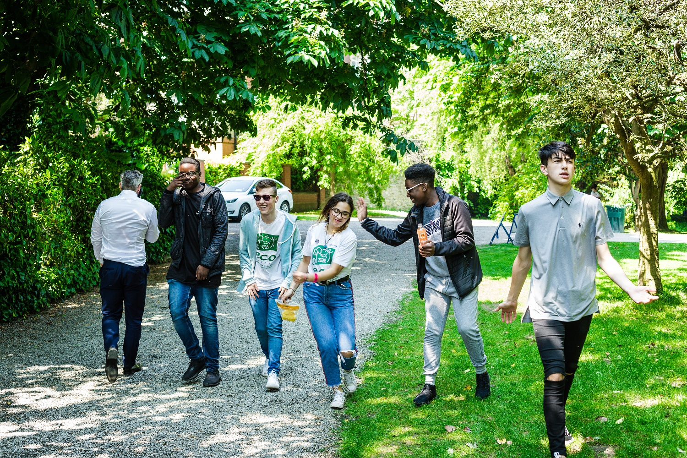

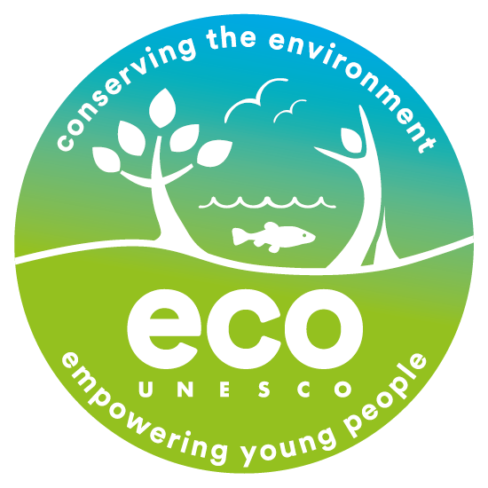

Candidate Information Pack
Operations and Development Manager
ECO-UNESCO
July 2022

About ECO-UNESCO
We are a leading environmental education and youth organisation working to channel the passion, creativity, and energy of young people into positive environmental action. Through our range of programmes and services we inspire, educate, empower, and support young people to act.

We work
“Our vision is a sustainable world where young people are actively engaged in protecting the environment.”

- across the island of Ireland
- to conserve the environment and empower young people.
- with young people in formal and non-formal education settings, in secondary schools, youth services
- with communities across Ireland through our Young Environmentalist Awards, workshops, trainings or affiliated ECO-UNESCO Clubs and groups.
- with partners in Europe and internationally.

Our Mission
Our mission is to protect the natural environment and empower young people by developing their knowledge, skills and confidence that channels their passion into positive and creative actions that helps create a sustainable planet. We do this by:
- Raising awareness, understanding and knowledge of the natural environment among young people.
- Engaging, inspiring and empowering young people by facilitating their personal development and well-being through practical environmental projects, activities and skills development.
- Promoting the protection and conservation of the environment by empowering young people to lead in action oriented environmental projects and activities and by promoting positive and environmental behaviour.
- Advocating for environmental education, education for sustainable development, the natural environment and youth development.
- Promoting the ideals of UNESCO and working with likeminded organisations in Europe and globally.

Our Values
We have respect for young people, our participants, volunteers, employees, and our stakeholders. In our work we have a passion for the environment and for our young people, and an acknowledgement that the natural environment plays an important role in all our lives and in the development and education of our young people. We value youth-led approaches, creativity and innovation, action based learning, and fun as we work together to protect the environment and impact the lives of young people.
What we do
ECO-UNESCO’s programmes empower and support young people to take action to protect and conserve the natural environment.
- Through education for sustainable development and environmental education we build knowledge and skills in young people and explore attitudes and values.
- We take a youth centred approach and promote learning for, about and in the environment
- We develop leadership skills, confidence, self-belief, and self-esteem
- We provide an opportunity for young people to feel socially engaged and make new friends
- We include young people’s views – they decide, they plan, they act, and they engage their peers.
How we do it
Our work can be broken down into the following categories
Environmental Youth Work
- Youth for Sustainable Development and Peer Education Programme
- Environmental youth events, activities, and workshops
- ECO-Youth Choices Health & Wellbeing
- Youth Climate Justice
- International Youth Summits
- Clubs Programme
Awards
- Our Annual Young Environmentalist Awards
Capacity Building and Training
- Information, training and supports provided to educators, youth leaders and young people
- Green Youth Employment programmes
- Training including QQI accredited courses delivered to a wide audience
- Development of environmental education resources
- ECO-Sustainability Award for organisations
Other Activities
- Representation and advocacy for environmental education and education for sustainable development (ESD)

About The Role
ECO-UNESCO is now seeking to recruit a highly experienced professional as its Operations and Development Manager. This is a great opportunity to join an organisation that is making a real difference to the lives of young people and the environment. If you have a passion for youth development and environmental education, are enthusiastic, motivated with great people management and organisation skills then we would love to hear from you.
. The role offers an exciting opportunity to work in a growing environmental youth organisation. Reporting to the National Director (CEO) and working as part of the senior management team, the Operations and Development Manager will be responsible for ensuring the efficient and effective management and delivery of programmes and services. As Operations and Development you will lead and support ECO-UNESCO’s operations, working closely with the team to ensure delivery of consistently high-quality programmes and services. You will work closely with the team in providing critical services and supports to the National Director and will work as part of the senior management team to translate strategic plans into action plans and objectives and will be responsible for identifying and developing opportunities for funding to achieve the organisations strategic goals as well as monitoring and controlling activities against budgets, complying with funder requirements and producing reports. You will effectively manage, lead and motivate the team to create an environment to ensure the objectives of ECO-UNESCO are met and the team reach their potential.

To be considered for this role you should come to us with a passion for our organisations aims of protecting the environment and engaging, educating and empowering young people to channel their passion and energy into positive environmental action. You should have excellent strategic and organisational skills, with an ability to prioritise, plan and organise your own and others’ workloads effectively and work under pressure to meet deadlines. A proven track record of leading, communicating, implementing and managing is essential, as is the ability to solve complex problems and resolve difficult situations.
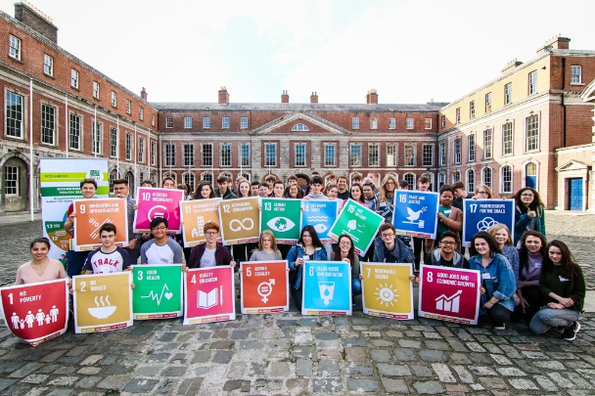

Main duties and responsibilities:

The Operations and Development Manager will
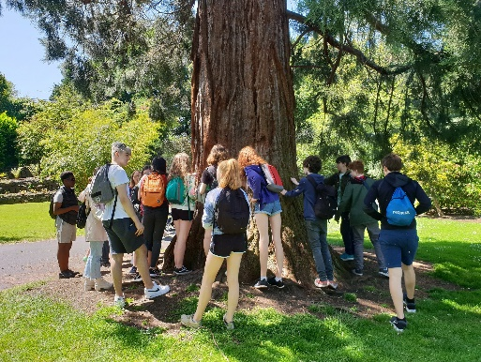
- Manage the effective implementation of ECO-UNESCOs Programmes and Services to ensure the growth of its youth environmental education programmes, including staffing, scheduling, monitoring and reporting.

- Work with the National Director to grow the reach of ECO-UNESCO programmes, identifying opportunities and submitting funding proposals to deadlines.

- Support the National Director and the Board of Directors in achieving ECO-UNESCO strategic objectives and translate strategic plans into action plans and objectives identifying and developing opportunities for funding as well as monitoring and controlling activities against budgets, complying with funder requirements and producing reports.

- Lead on the organisations operations to ensure an efficient and effective organisation including systems, financial and facilities. Oversee and manage the Salesforce CRM, ensuring its consistent use for the organisations work.

- Provide ongoing motivation, support, line-management, and coaching to members of the Programmes Team, to create an environment where staff feel supported to achieve the goals and objectives of ECO-UNESCO, setting work plans and reviewing progress to drive great performance and development of the team.

- Manage and oversee ECO-UNESCO’s Quality Assurance Systems including the Monitoring and Evaluation System, QQI Quality Assurance, National Quality Standards Framework for Youth Work, IDEA Code of Good Practice in Development Education.

- Support the organisations work on compliance

- Help promote and increase the awareness of ECO-UNESCO’s programme to stakeholders and monitor the reach of ECO-UNESCO’s programmes and services.

- Oversee and manage contact and liaising with key agencies

- Furnish reports on a regular basis

- Undertake any other such relevant duties as directed

- Duties, performance and targets will be reviewed on an on-going basis.
The Right Person
The successful candidate will be an experienced Operations and Development who is a highly organised planner and implementer, with a focus on driving great performance, motivating a team and achieving targets. They will be a strategic thinker, be innovative, enthusiastic self-starter, with a proactive, solution-focused outlook. They will have confidence in working with a wide variety of stakeholders and service users, the ability and willingness to be hands-on and will be very personable and cooperative.

ECO-UNESCO is young person centred and our programmes and initiatives on the environment are engaging, empowering, educational and fun. Anyone who joins, should have personal values that are in-line with those of ECO-UNESCO.

Core Competencies:
- Planning and Organising and deadline-oriented
- Leadership
- Team Work
- Critical Thinking and Problem Solving
- Data analysis and decision making
- Interpersonal and relationship building
- Communication

Qualifications:
- A relevant third level qualification (E)
- A qualification in management and/or education management (D)

Experience
- At least 4 years’ experience in a similar position and a proven track record of managing projects and people effectively. (E)
- Familiarity and experience in youth work / education / formal and non-formal education / education for sustainable development/environmental education or community and voluntary sectors (E)
- Experience in managing the implementation of programmes and services, driving growth and achieving KPI’s (E)
- Experience in applying for funding and reporting on outcomes.(E)
- Experience in managing budgets, systems and supporting compliance in an organisation. (E)
- Very good funding, financial, budgeting and analytical understanding. (E)
- Strong writing and reporting (D)
- Strong IT skills, including database management (D)
- A full clean driving license (D)

Disposition
- Be a self-starter with a positive, can-do attitude at all times
- Be dependable and flexible
- Be committed to working as part of a team with a commitment to the values and principles of ECO-UNESCO
Key information about this role
- The salary for this position is in the range of €50,000 - €55,000, the starting salary will depend on experience.
- This is a full-time role over 35 hours per week. Evening and weekend work will be required.
- The position is based at ECO-UNESCO’s Offices at 9 Burgh Quay, Dublin 2 with hybrid working options
- The role will require occasional nationwide travel
- 21 days annual leave per year which increases annually to a maximum of 25 days per year.
- An employer matched pension scheme is available after a qualifying period.
- An Employee Assistance Programme is available to all staff.

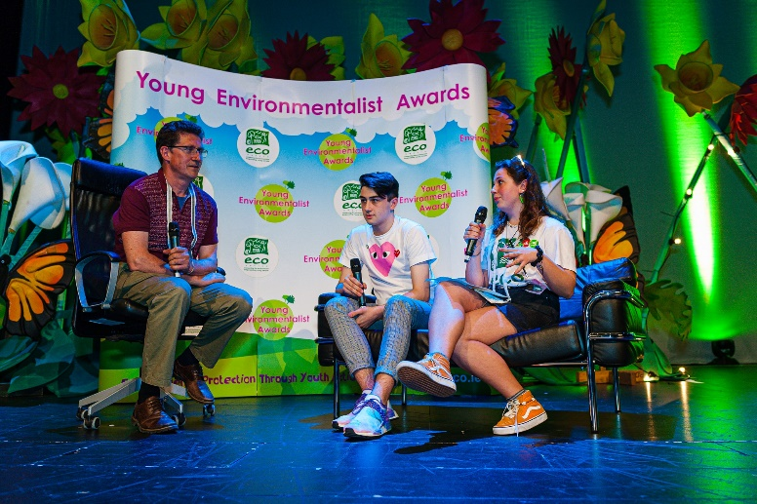
This position is funded under the Special Scheme for National Organisations administered by Pobal on behalf of the Department of Rural and Community Development.

How to apply

Please complete the Application form (below) and send with a cover letter to recruitment@ecounesco.ie or return it by post to:

Employment Opportunities

(Operations and Development Manager)

ECO-UNESCO

9 Burgh Quay

Dublin 2

Ireland

The closing date for applications is Midnight 17th August 2022
Once the closing date passes, applications will be received, and a shortlist of candidates will be invited to interview.
Interviews will be competency based and seek to better understand your background, skills, and experience.
2nd round interviews may be conducted where the panel feel there is a need.
Candidates will be subject to Garda Vetting
Candidates may be placed on a panel for suitable future positions that may become available.
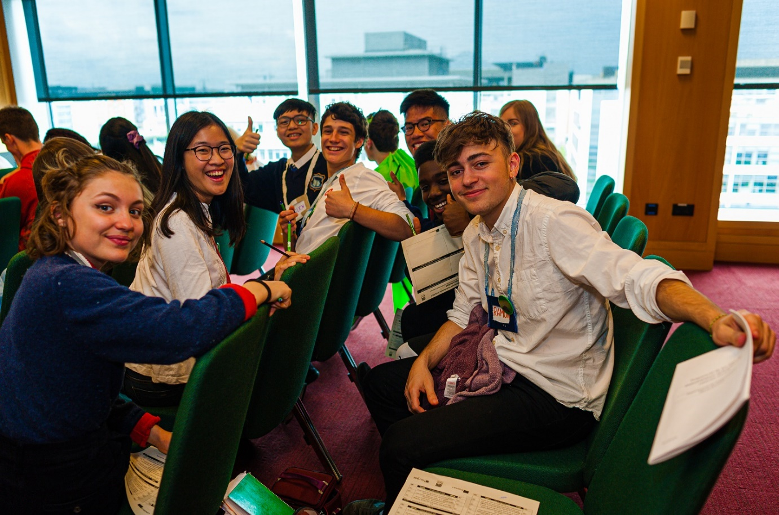

ECO-UNESCO

APPLICATION FOR EMPLOYMENT

Please complete all sections of the form. CV’s are not accepted, and no application will be processed of the form is incomplete.
Position applied for:
Where did you see the post advertised?

Personal Details
Title
Surname
Forename(s)
Address
Phone
E-mail

Current or Last Employment
Position
Employer
Date from/to
Summary of achievements

Previous Employment (please add more rows if required)
Employer: | From: | To: | Position:
Summary of achievements:

Employer: | From: | To: | Position:
Summary of achievements:

Employer: | From: | To: | Position:
Summary of achievements:

Employer: | From: | To: | Position:
Summary of achievements:

Education and Qualifications
School / college / university… | From | To | Qualifications

Language Skills
 |  | Fluent | Moderate | Learning | None
ENGLISH | Speaking
 | Writing
IRISH | Speaking
 | Writing
Add additional languages (with levels), or comments:

Experience & Skills
Please detail how your skills and experience meet the requirements set out in the job description. Before completing this section, please read the job description for this post carefully. For each item in the person specification (except formal qualifications already listed), you should give examples from your past employment, interests, voluntary work or life experiences to demonstrate how you meet the requirements of the post.

Statement in support of your application
Please outline motivations for wanting this post.

Additional Questions
If successful, what is the earliest date that you could start the job?
Do you hold a current, full and clean Driving License valid in the Republic of Ireland? |  |  | Yes / No  (desirable but not essential)
References
Please provide details of two referees, including your present or most recent employer. We will not contact your referees until we have informed you and received your consent. Please ensure you have your referee’s permission to share their contact information.
1 | Name
 | Position
 | Address
 | Tel. No.
 | E-mail

2 | Name
 | Position
 | Address
 | Tel. No.
 | E-mail

Declaration
I declare that the statements made by me in this application are true and that the accuracy thereof shall be a condition of any contract of employment offered to me by ECO-UNESCO:

Signature of Applicant
Date

Please e-mail your completed form to recruitment@ecounesco.ie or return it by post to:

Employment Opportunities

(Programme Coordinator - YSD)

ECO-UNESCO

9 Burgh Quay

Dublin 2

Ireland

Closing date for applications is Midnight Wednesday 17th August

