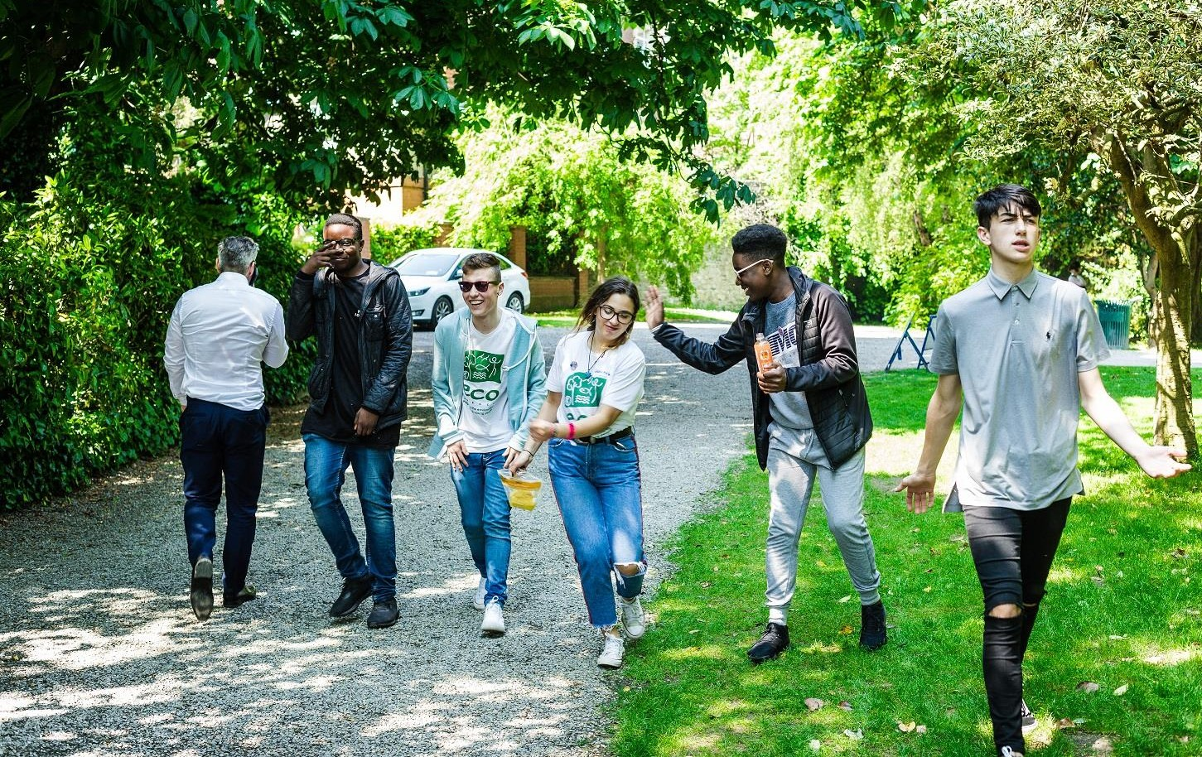

Candidate Information Pack

Project Officer – Youth for Sustainable Development
ECO-UNESCO
2022

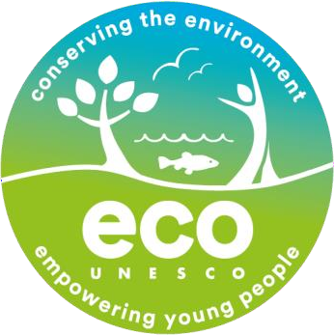

About ECO UNESCO

We are a leading environmental education and youth organisation working to channel the passion, creativity, and energy of young people into positive environmental action. Through our range of programmes and services we inspire, educate, empower, and support young people to act.

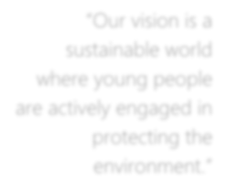We work
“Our vision is a sustainable world where young people are actively engaged in
protecting the
environment.”
- across the island of Ireland
- to conserve the environment and empower young people.
- with young people in formal and nonformal settings, in secondary schools, youth services
- and communities across Ireland through our Young Environmentalist Awards, workshops, trainings or one of our affiliated ECO-UNESCO Clubs.
- and with partners in Europe and internationally.

Our Mission
Our mission is to protect the natural environment and empower young people by developing their knowledge, skills and confidence that channels their passion into positive and creative actions that helps create a sustainable planet. We do this by:
- Raising awareness, understanding and knowledge of the natural environment among young people.
- Engaging, inspiring and empowering young people by facilitating their personal development and well-being through practical environmental projects, activities and skills development.
- Promoting the protection and conservation of the environment by empowering young people to lead in action oriented environmental projects and activities and by promoting positive and environmental behaviour.
- Advocating for environmental education, education for sustainable development, the natural environment and youth development.
- Promoting the ideals of UNESCO and working with likeminded organisations in Europe and globally.

Our Values
We have respect for young people, our participants, volunteers, employees, and our stakeholders. In our work we have a passion for the environment and for our young people, and an acknowledgement that the natural environment plays an important role in all our lives and in the

development and education of our young people. We value youth-led approaches, creativity and innovation, action based learning, and fun as we work together to protect the environment and impact the lives of young people.

What we do
ECO-UNESCO’s programmes empower and support young people to take action to protect and conserve the natural environment.
- We take a youth centred approach and promote learning for, about and in the environment
- We develop leadership skills, confidence, self-belief, and self-esteem
- We provide an opportunity for young people to feel socially engaged and make new friends
- We include young people’s views – they decide, they plan, they act, and they engage their peers.

How we do it
Our work can be broken down into the following categories

Environmental Youth Work
- Youth for Sustainable Development and Peer Education Programme
- Environmental youth events, activities, and workshops
- Clubs Programme
- ECO-Youth Choices Health & Wellbeing
- International Youth Summit - #NoTimeToWaste
- Youth Climate Justice

Capacity Building and Training
- Green Youth Employment programmes
- Information and support provided to educators, youth leaders and young people
- Training including QQI accredited courses delivered to a wide audience
- Key Partner of the UNESCO Global Action Programme in Education for Sustainable Development

Awards
- Our Annual Young Environmentalist Awards

Other Activities
- Development of environmental education resources
- ECO-Sustainability Award for organisations
- Representation and advocacy for environmental education and education for sustainable development (ESD)

About The Role
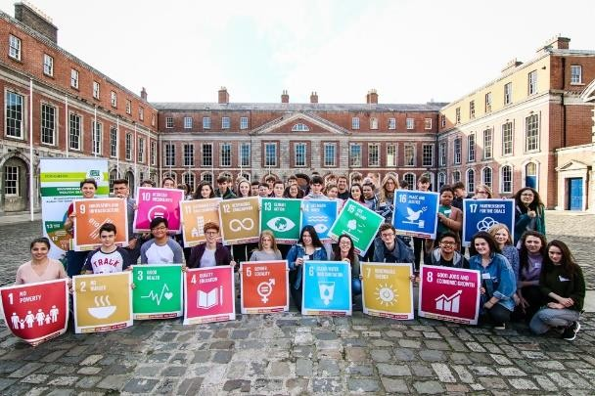
ECO-UNESCO seeks to employ a Project Officer for our Youth for Sustainable Development (YSD) programme. This is a position of responsibility within ECO-UNESCO. You will assist with the delivery of our Youth for Sustainable Development (YSD) programme, including recruitment of participants, setting up clubs, developing content, planning and direct workshop delivery.

About the YSD Programme

The Youth for Sustainable Development (YSD) programme is a non-formal youth club running in various locations around Ireland. The core of the programme is built around the delivery of a 12- week programme consisting of workshops, talks, events and games.
Participants take a deep dive into the key sustainability issues facing our world and learn how interconnected all our problems and solutions really are. At the end of the 12-week programme, they are supported in undertaking an action project on an environmental topic of their choosing.
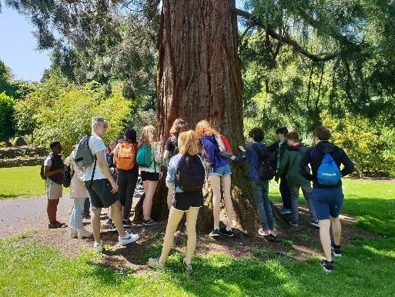
We offer participants QQI Level 5 Accredited Training in Peer Education. This elective element teaches participants to be self-confident facilitators and passionate advocates for environmental sustainability.
Participants who remain with the programme can choose to take part in our Youth Leader programme, where they are given a leadership role and can co-facilitate sessions.

Key Responsibilities

Development and Implementation
- Assisting the running of the YSD Global Youth Leaders for Change Youth Peer Education Programmes and associated support programmes.
- Assisting in the implementation of the ECO-Sustainability Award for youth and community organisations.
- Organising events including workshops, seminars, and other events.
- Developing, promoting, and implementing training programmes for young people and youth leaders.
- Promoting the establishment of ECO-UNESCO /YSD clubs regionally; assisting in volunteer recruitment, training, and support of clubs.
- Assisting in the delivery and running the YSD related QQI accredited training courses including, project support, marking and administration.

- Researching and writing materials as needed
- Developing and delivering identified outreach workshops
- Supporting in other ECO-UNESCO programmes as required

Promotion
- Promoting ECO-UNESCO’s YSD and development education programme through talks and
presentations.

Other
- Updating all participant information in Salesforce
- Completing Monitoring and Evaluation activities on a regular basis
- Undertaking any other such relevant duties as directed
- Assisting in any other areas of ECO-UNESCO work
- Representing ECO-UNESCO on relevant ESD and DE bodies.

This role description is not to be regarded as exclusive or exhaustive. It is intended as an outline indication of the areas of activity and can be amended. ECO-UNESCO reserves the right to reassign staff as appropriate and necessary.

The Right Person

Qualifications
- 3rd Level Qualification in a related field – in sustainable development/environmental studies or science / ecology/biology/ geography/ education
- An education or youth work qualification would be beneficial

Experience
- At least 2 years work experience in direct work with and young people (10-18); youth work, education and/or environmental education/sustainable development and /or in a similar youth scheme/programme
- Experience in developing and delivering youth, education and training programmes
- Demonstrable organization skills, having managed multiple priorities and adherence to deadlines
- Budgetary management experience from initial planning through to end of project reporting.
- A strong interest in the environment international development and working with young people.
- A full, clean driving license.

Knowledge and Skills
- Knowledge of the youth work sector and education system in Ireland
- Knowledge of education for sustainable development/development education in Ireland
- Knowledge of international development issues including climate justice & food security
- Excellent organisational skills
- Excellent communications and interpersonal skills
- Excellent report writing, analytical and computer skills
- Ability to work to tight deadlines and under pressure
- Ability to manage a complex workload
- Working knowledge of IT systems
- Ability to critically analyse data and make appropriate decisions
- Ability to work as part of a team

Disposition
- Be a self-starter with a positive, can-do attitude at all times
- Be dependable and flexible
- Be committed to working as part of a team with a commitment to the values and principles of ECO-UNESCO
- Be able to take direction

Key information about this role
- This is a Full-time role over 35 hours per week. Evening and weekend work will be required.
- The position is based at 9 Burgh Quay, Dublin 2.
- The role will require regular nationwide travel to deliver youth activities.
- 21 days annual leave per year which increases annually to a maximum of 25 days per year.
- An employer matched pension scheme is available after a qualifying period.
- An Employee Assistance Programme is available to all staff.

How to apply
Please e-mail your completed application form to recruitment@ecounesco.ie, or return it by post to:
- Employment Opportunities
- (Project Officer - YSD)
- ECO-UNESCO
- 9 Burgh Quay
- Dublin 2
- Ireland

- The closing date for applications is Midnight 9th December 2022

ECO-UNESCO APPLICATION FOR EMPLOYMENT

Please complete all sections of the form. CV’s are not accepted, and no application will be processed of the form is incomplete.

Position applied for:
Where did you see the post advertised?

Personal Details
Title
Surname
Forename(s)
Address
Phone
E-mail

Current or Last Employment
Position
Employer
Date from/to

Summary of achievements

Previous Employment (please add more rows if required)
Employer: | From: | To: | Position:
Summary of achievements:
Employer: | From: | To: | Position:
Summary of achievements:
Employer: | From: | To: | Position:
Summary of achievements:
Employer: | From: | To: | Position:
Summary of achievements:

Employer: | From: | To: | Position:
Summary of achievements:
Employer: | From: | To: | Position:
Summary of achievements:

Education and Qualifications
School / college / university… | From | To | Qualifications

Language Skills
 |  | Fluent | Moderate | Learning | None
ENGLISH | Speaking
 | Writing
IRISH | Speaking
 | Writing
Add additional languages (with levels), or comments:

Experience & Skills
Please detail how your skills and experience meet the requirements set out in the job description. Before completing this section, please read the job description for this post carefully. For each item in the person specification (except formal qualifications already listed), you should give examples from your past employment, interests, voluntary work or life experiences to demonstrate how you meet the requirements of the post.

Statement in support of your application
Please outline motivations for wanting this post.

Additional Questions
If successful, what is the earliest date that you could start the job?
Do you hold a current, full and clean Driving License valid in the Republic of Ireland? |  |  | Yes / No  (desirable but not essential)
References
Please provide details of two referees, including your present or most recent employer. We will not contact your referees until we
have informed you and received your consent. Please ensure you have your referee’s permission to share their contact information.
1 | Name
 | Position
 | Address
 | Tel. No.
 | E-mail

2 | Name
 | Position
 | Address
 | Tel. No.
 | E-mail

Declaration
I declare that the statements made by me in this application are true and that the accuracy thereof shall be a condition of any contract of employment offered to me by ECO-UNESCO:
Signature of Applicant
Date

Please e-mail your completed form to recruitment@ecounesco.ie or return it by post to:

Employment Opportunities Project Officer – YSD
ECO-UNESCO
9 Burgh Quay
Dublin 2 Ireland

Closing date for applications is 9th December 2022

