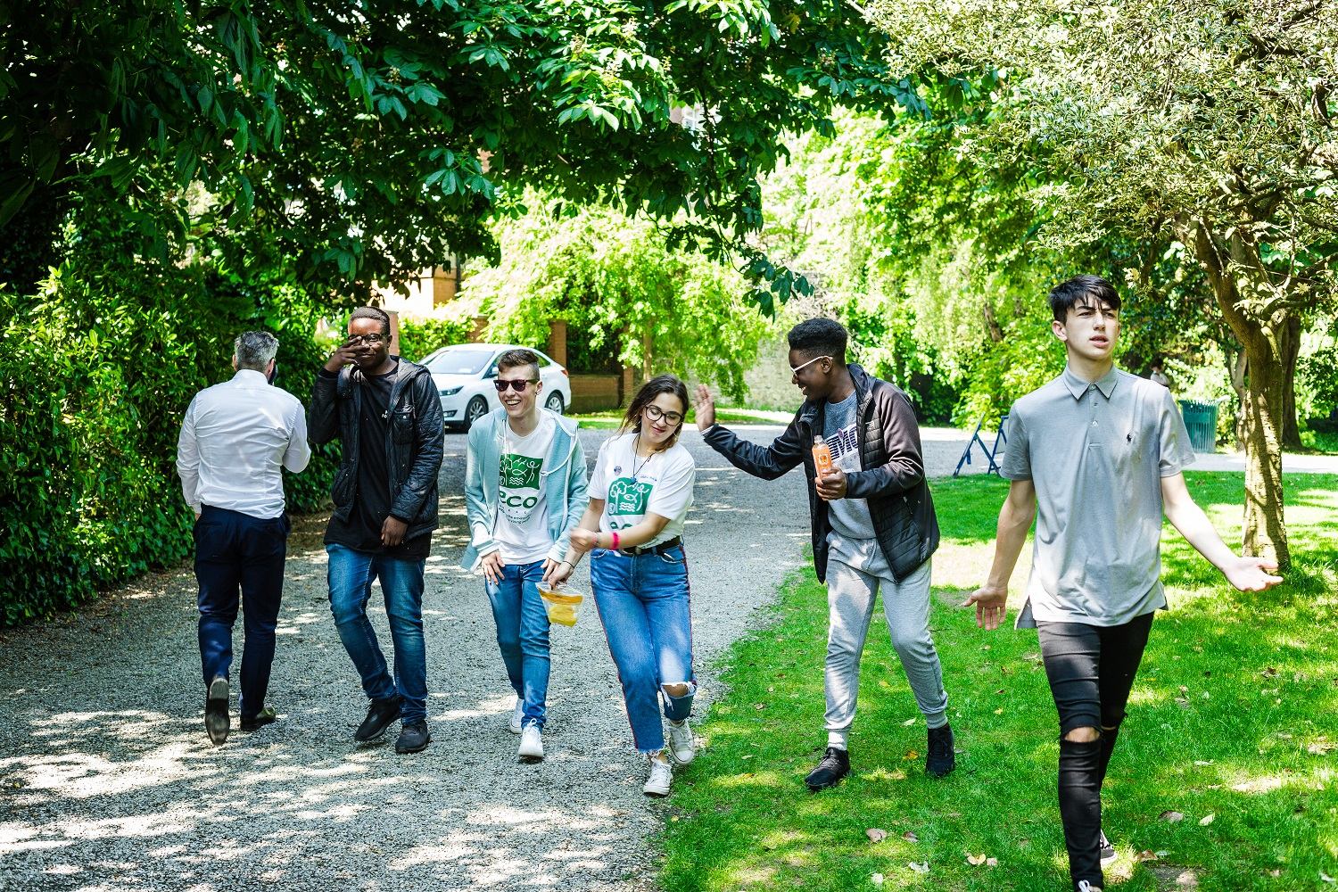

Candidate Information Pack
Regional Development Officer
ECO-UNESCO

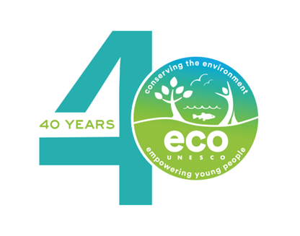
www.ecounesco.ie
About ECO-UNESCO
We are an environmental education and youth development organisation working across the island of Ireland, dedicated to promoting sustainable development through education, youth engagement and community action. Established in 1986, the organisation works to empower young people with the knowledge and skills to take action on environmental issues through programmes, workshops, and training focused on climate action, biodiversity and sustainable living.

Our Vision
Our vision is a sustainable world where young people are actively engaged in protecting the environment.

Our Mission
Our mission is to protect the natural environment and empower young people by developing their knowledge, skills and confidence that channels their passion into positive and creative actions that helps create a sustainable planet.

Our Values
We have respect for young people, our participants, volunteers, employees and our stakeholders. In our work we have a passion for the environment and for our young people, with an acknowledgement that the natural environment plays an important role in all our lives and in the development and education of our young people. We value youth-led approaches, creativity and innovation, action-based learning and fun, as we work together to protect the environment and impact the lives of young people.

What we do
ECO-UNESCO’s programmes empower and support young people to take action to protect and conserve the natural environment.
- We take a youth-centred approach and promote learning for, about and in the environment
- We develop leadership skills, confidence, self-belief and self-esteem
- We provide opportunities for young people to feel socially engaged and make new friends
- We include young people’s views – they decide, they plan, they act and they engage their peers
How we do it
Our work can be broken down into the following categories:

Environmental Youth Work
- Youth for Sustainable Development and Peer Education Programme
- Environmental youth events, activities, and workshops
- Clubs Programme
- ECO-Choices Health & Wellbeing
- International Youth Summit - #NoTimeToWaste
- Youth Climate Justice
Capacity Building and Training
- Green Youth Employment programmes
- Information and support provided to educators, youth leaders and young people
- Training including QQI accredited courses delivered to a wide audience
- Key Partner of the UNESCO Global Action Programme in Education for Sustainable Development
Awards
- Our annual Young Environmentalist Awards
Other Activities
- Development of environmental education resources
- ECO-Sustainability Award for organisations
- Representation and advocacy for environmental education and education for sustainable development (ESD)

Regional Development Officer - Ulster / Connacht / Munster
This is a great opportunity to join an organisation that is protecting the natural environment and making a real difference to the lives of young people. We are currently recruiting three Regional Development Officers to support our work across the island of Ireland, with dedicated roles in Ulster, Connacht and Munster. If you have a passion for our natural environment, for youth development and are pro-active, with strong communication and organisational skills, with a background in sustainability, then we would love to hear from you.

Contract: 2 years Fixed term (*subject to ongoing funding)
Probationary period: 6 months

About The Role
As Regional Development Officer, the person will be responsible for supporting ECO-UNESCO to develop and grow its impact, as part of the organisation’s ambitious Strategic Plan 2025-2028. The role will include:
- Partnership and Stakeholder Engagement – this will include developing and building relationships with schools, Local Authorities and Education and Training Boards and community groups among others to promote participation and collaboration.
- Regional Programme Delivery – this will include coordination and delivery of high-quality environmental programmes and workshops.
- Expansion and Strategic Growth – this will include outreach work, and identifying opportunities, partnerships and networks to support the expansion of programmes.
- Training and Capacity Building – this will include delivering training to educators and youth leaders to strengthen local delivery capacity.
- Monitoring and Reporting – tracking participation, monitoring progress, collecting data and preparing reports to evaluate programme outcomes, impact and ensure targets are met.

Reporting to: | Operations & Programme Manager
Location: | Remote Working – these are field-based roles covering Ulster, Connacht and Munster, with occasional office attendance
Time commitment: | Full time (35 hours), Fixed Term Contract  Flexibility is required for this role as there is regular evening and weekend work involved.
Start Date: | Immediate
Salary: | Starting salary scale €35,000-€39,000. Salary dependant on experience.

Benefits
- 21 days annual leave per year which increases annually to a maximum of 25 days per year
- An employer matched pension scheme is available after a qualifying period
- An Employee Assistance Programme is available to all staff
- Use of a Mobile Phone and Laptop
- Bike to work & TaxSaver travel schemes
- Exam and study leave

Key Responsibilities

Partnership and Stakeholder Engagement
Develop and strengthen strategic relationships with a wide range of education and community partners to embed environmental learning across the region.
This will include:
- Building and maintaining trusted relationships with schools, Local Authorities, and Education and Training Boards among others.
- Engaging with school leaders, teachers, and youth coordinators to understand local needs and tailor programme offerings.
- Managing communication channels with stakeholders including regular communications and meetings, to maintain strong, consistent engagement.
- Acting as the primary contact point regionally, ensuring partners feel supported, informed, and involved in programme development.

Regional Programme Delivery
Lead the coordination and delivery of ECO-UNESCO’s high-quality environmental education programmes regionally.
This will include:
- Planning and overseeing the rollout of ECO-UNESCO programmes across schools, youth groups and community groups, ensuring consistency and quality.
- Facilitating sessions, workshops, and school visits to support ECO-UNESCOs programmes including the Young Environmentalist Awards, Workshops, QQI trainings.
- Monitoring programme delivery against KPIs such as participation, learning outcomes, and impact metrics.
- Gathering data, testimonials, and case studies to demonstrate impact and inform future development.

Expansion and Strategic Growth
Identify and pursue opportunities that support regional expansion and long-term sustainability of programmes.
This will include:
- Mapping the regional landscape to identify gaps, growth opportunities, and new partnership opportunities in education, community, local authority and environmental sectors.
- Building relationships with potential new partners such as NGOs, corporate funders, community groups, or universities.
- Working with senior leadership to develop regional growth plans and pilot new initiatives.
- Contributing to funding applications or collaborative projects that support programme scaling.
- Ongoing review of participation data and opportunities to help guide improvements and expansion of work.

Training & Capacity Building
Strengthen the capacity of educators and stakeholders to deliver high-quality environmental education. This will include:
- Delivering ECO-UNESCO workshops and trainings for teachers, youth workers, and community educators.
- Providing training materials, resources, and follow-up support for educators.
- Collecting feedback on training content and ensure continuous improvement.

- Revenue Generation & Promotion

- To achieve revenue targets for workshop delivery on a paid basis.
- To build a sales pipeline through the development and implementation of a promotion plan, ensuring all schools and youth groups are aware of our offerings.
- To ensure schools and youth groups we work with are made aware of all relevant ECO-UNESCO programmes.
Other
- Assisting delivery of ECO-UNESCO’s other programmes as needed. Periodic assistance is required from all staff for our annual Young Environmentalist Awards, Youth Summit, and other key events.
- To work with Programmes Manager and Head of Fundraising and Business Development in identifying and responding to funding and PR opportunities.
- Undertaking any other such relevant duties as directed.
- Representing ECO-UNESCO on relevant ESD and DE bodies if relevant.
- To maintain all relevant files and records, including Salesforce.
This role description is not to be regarded as exclusive or exhaustive. It is intended as an outline indication of the areas of activity and can be amended. ECO-UNESCO reserves the right to reassign staff as appropriate and necessary.

Person Specification
Qualifications
- 3rd Level Qualification in a related field – in sustainable development/environmental studies or science/ecology/biology/ geography/ education (Essential)
- An education or youth work qualification (Desirable)
Experience
- At least 2+ years' work experience in direct work with young people (10-18); youth work, education and/or environmental education/sustainable development and /or in a similar youth scheme/programme (Essential)
- Experience in developing and delivering youth, education and training programmes (Essential)
- Demonstrable organisation skills, having managed multiple priorities and adherence to deadlines (Essential)
- Budgetary management experience from initial planning through to end of project reporting (Desirable)
- A strong interest in the environment, international development and working with young people (Essential)
- A full, clean driving licence and access to a car (Essential)
Knowledge and Skills
- Knowledge of the youth work sector and education system in Ireland and/or Northern Ireland (Essential)
- Knowledge of education for sustainable development/development education in Ireland (Essential)
- Knowledge of international development issues including climate justice (Essential)
- Excellent communications and interpersonal skills (Essential)
- Excellent report writing, analytical and computer skills (Essential)
- Ability to manage a complex workload (Essential)
- Ability to critically analyse data and make appropriate decisions (Desirable)
- Ability to work as part of a team (Essential)
Disposition
- Be a self-starter with a positive, can-do attitude
- Be a problem solver and creative
- Be dependable and flexible
- Be able to take direction
- Be committed to working as part of a team
- Be committed to the values and principles of ECO-UNESCO

ECO-UNESCO is an equal opportunities employer and all employees are expected to develop an understanding of and commitment to equal opportunities.

How to apply
Please send a copy of a completed Application Form to: recruitment@ecounesco.ie
Please mark in the subject line Employment Opportunities – Regional Development Officer (Private and Confidential)
Closing Date for Applications – 22nd May 2026
Successful applicants may be requested to prepare a short presentation during the selection process.

Applicants may be placed on a panel for positions that may arise in the future.

By completing and submitting this form you consent to ECO-UNESCO processing the personal data provided to assess this application for employment. No further processing of your data will occur beyond this purpose. ECO-UNESCO will retain this application for up to 12 months, after which it will be deleted.

Candidates, depending on the nature of the role, may be subject to Garda Vetting.

ECO-UNESCO

APPLICATION FOR EMPLOYMENT

Please complete all sections of the form. CVs are not accepted, and no application will be processed if the form is incomplete.

Position applied for: | Regional Development Officer
Where did you see the post advertised?
Regional area applied for (Munster, Connacht, Ulster)

Personal Details
Title
Forename
Surname
Address
Please note, any successful candidate will have to be resident in Ireland upon taking up the position.
Phone
E-mail

Current or Last Employment
Position
Employer
Date from/to
Summary of achievements

Previous Employment (please add more rows if required)
Employer: | From: | To: | Position:
Summary of achievements:
Employer: | From: | To: | Position:
Summary of achievements:
Employer: | From: | To: | Position:
Summary of achievements:
Employer: | From: | To: | Position:
Summary of achievements:
Employer: | From: | To: | Position:
Summary of achievements:

Education and Qualifications
School/college /University… | From | To | Qualifications

Language Skills
 |  | Fluent | Moderate | Learning | None
ENGLISH (fluency essential) | Speaking
 | Writing
IRISH | Speaking
 | Writing
Add additional languages (with levels), or comments:

Relevant Experience
Detail how your skills and experience meet the requirements set out in the Job Description
3rd Level Qualification in a related field – in sustainable development/environmental studies or science / ecology/biology/ geography/ education | Please provide details…
At least 2 years work experience in direct work with young people (10-18); youth work, education and/or environmental education /sustainable development and /or in a similar youth scheme/programme | Please provide details…
Experience in Partnership and Stakeholder Engagement | Please provide details…
Experience in developing and delivering youth, education and training programmes | Please provide details…
Demonstrable organisation skills, having managed multiple priorities and adherence to deadlines | Please provide details…
Knowledge of the youth work sector and education system in Ireland | Please provide details…
Relevant interests | Please provide details…

Statement in support of your application
Please outline your motivation for applying for this post.

Additional Questions
If successful, what is the earliest date that you could start the job?
Do you hold a current, full, and clean Driving License valid in the Republic of Ireland? |  |  | Yes / No  (Essential)
Is there anything else you feel we need to know to support you in your application?
References
Please provide details of two referees, including your present or most recent employer. We will not contact your referees until we have contacted you and received your consent. Please ensure you have your referee’s permission to share their contact information.
1 | Name
1 | Position
1 | Address
1 | Tel. No.
1 | E-mail

2 | Name
2 | Position
2 | Address
2 | Tel. No.
2 | E-mail

Declaration
I declare that the statements made by me in this application are true and that the accuracy thereof shall be a condition of any contract of employment offered to me by ECO-UNESCO:

Signature of Applicant
Date

Please e-mail your completed form to recruitment@ecounesco.ie with Employment Opportunities – Regional Development Officer (Private and Confidential) in the subject line.
Closing Date for Applications – 22nd May 2026
Interview Date – provisionally first interviews scheduled for week commencing 25th May 2026

